README DOCUMENT

1. Download and unzip the file “Group31.zip”, which contains the following files:

* Project_PharmaScape_Oncology.py
* Amgen.py
* Merck.py
* Pfizer.py
* Clinical_Trails.py
* Control_file.py
* Tweet_Scrap.py
* Amgen.csv
* Merck.csv
* Pfizer_Breast.csv
* Pfizer_Lung.csv

Webscraping the data takes time, hence the csv files are provided in this directory.

*** The tweet_scrap.py file contains user-sensitive information. Please do not share.

*Directory Folder*

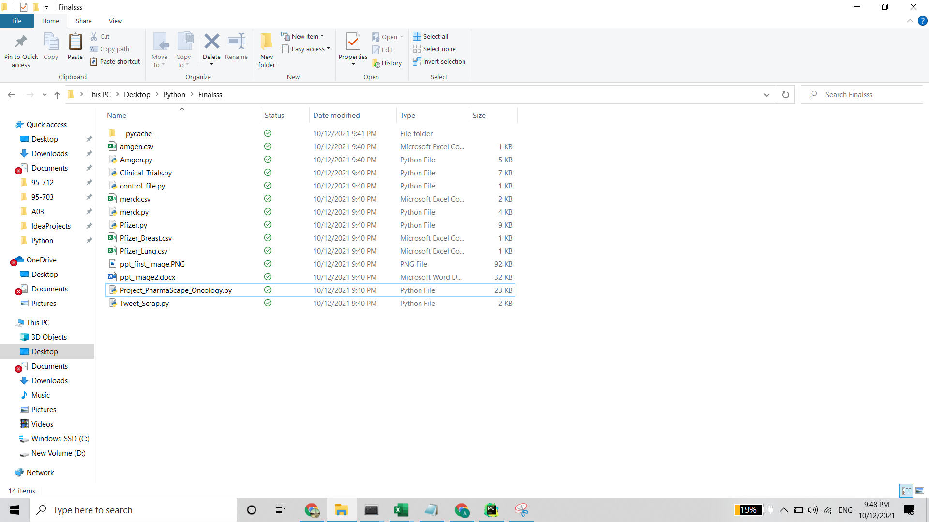

1. Open the file “Project_PharmaScape_Oncology.py” using Spyder.

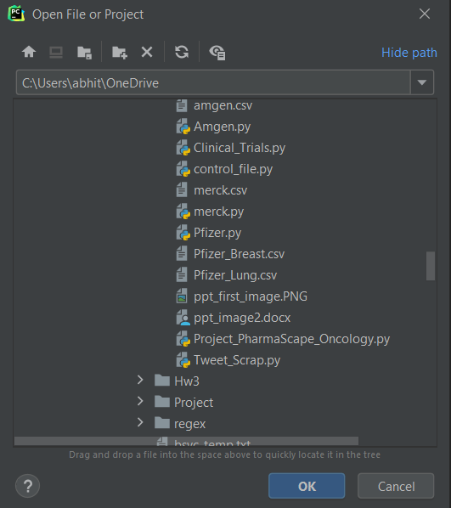

1. Ensure that the following libraries have been installed before running the program file:

* pandas – 1.2.4
* BeautifulSoup – 4.9.3
* numpy – 1.20.1
* requests – 2.25.1
* Matplotlib – 3.4.3
* selenium (pip install selenium) – 4.0.0
* webdriver (pip install webdriver_manager)
* chromedriver_binary
* By – 3.10.0
* Keys
* time
* re – 3.10.0
* ChromeDriverManager
* tkinter – 8.5.0
* tabulate – 0.8.0
* OAuthHandler – 4.1.0
* tweepy – 4.1.0
* pytrials – 0.2.0

1. According to the menu displayed, first select your preferred indication i.e Breast Cancer or Lung Cancer, then select the company of interest i.e Pfizer, Merck or Amgen, if selecting General Clinical Trials please go to step 7. After selecting the company, select the preferred information you would like to get regarding the products in the pipeline and the product porfolios or the recent tweets posted related to the company. You can see the tabulated data according to the preferences selected.

**OUTPUTS**

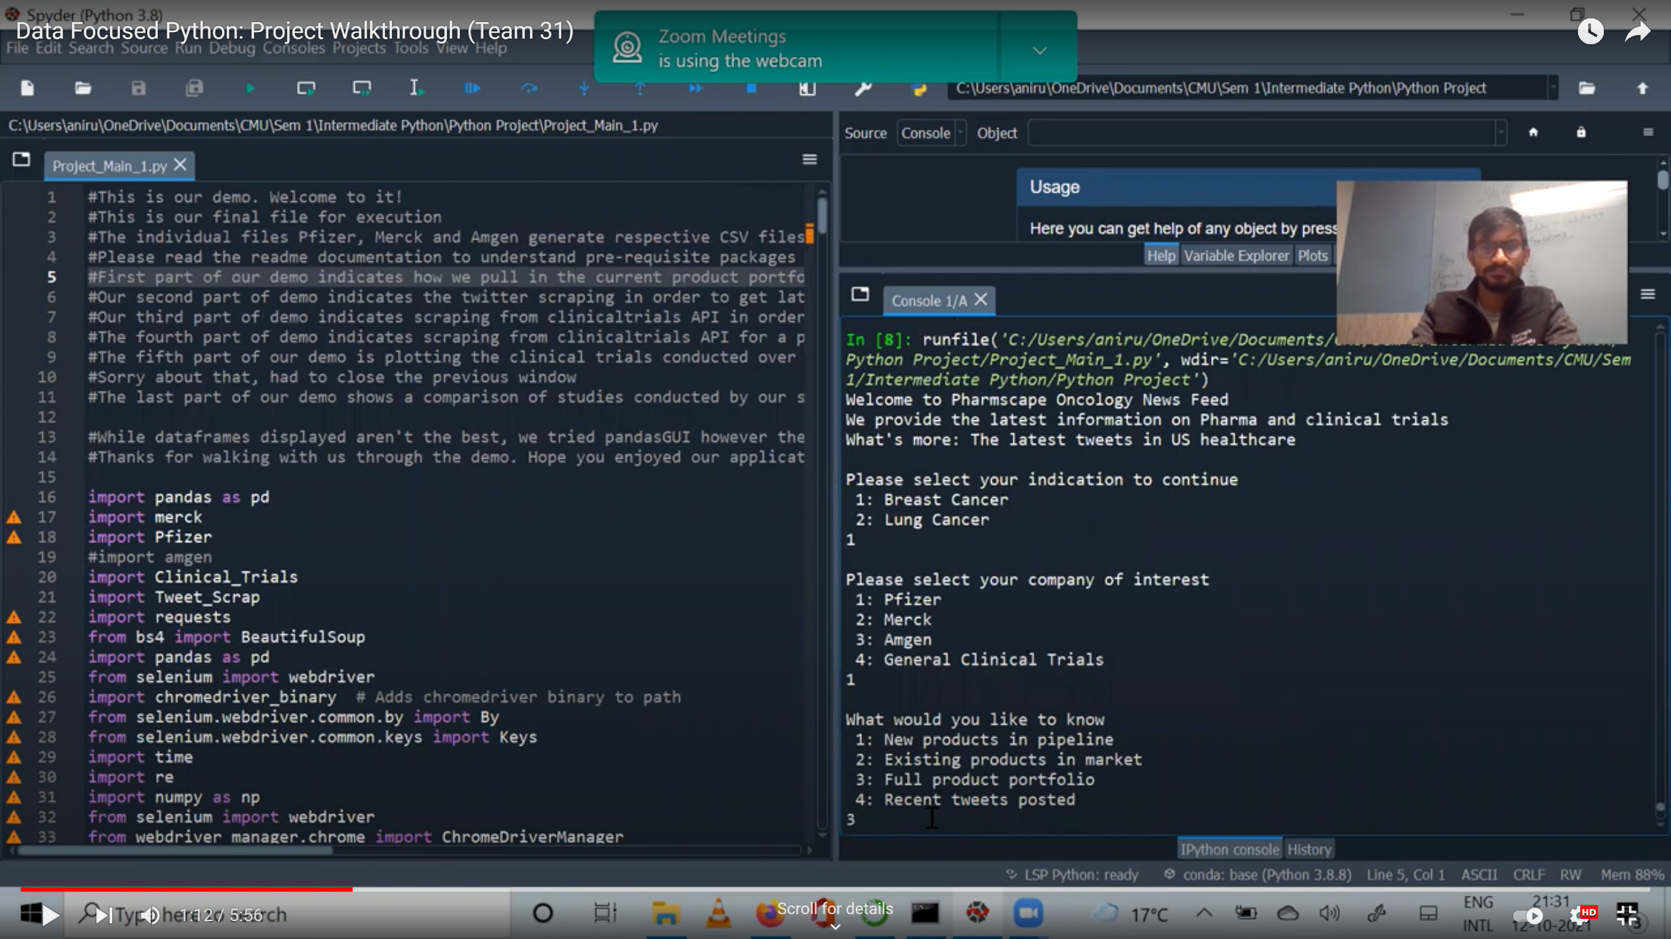

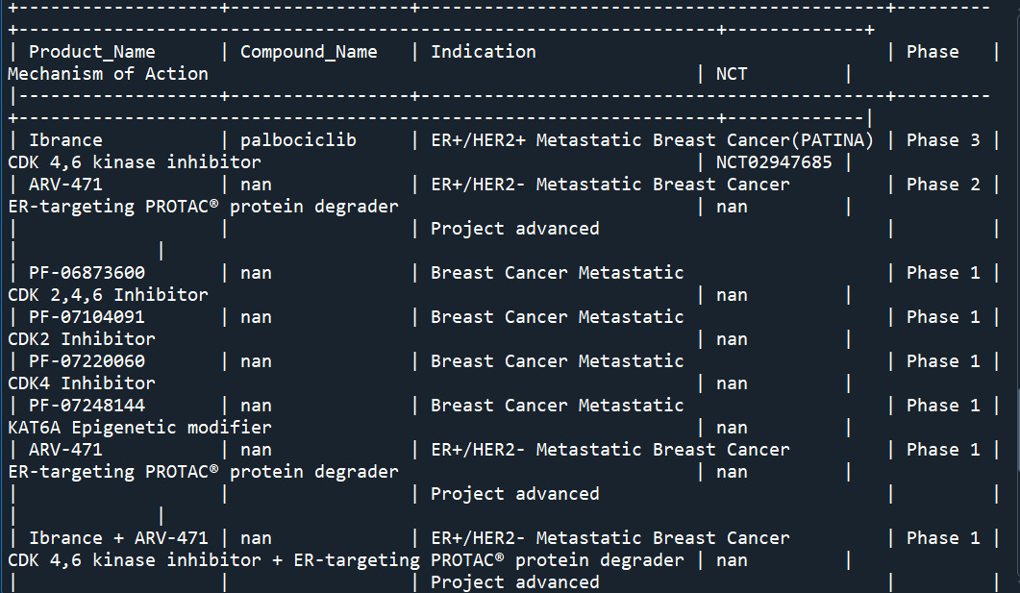

1. If General Clinical Trials is selected, in the next set of options, you can select the kind of information you would like to view, like the active trials in 2021, or trials for specific sponsor, to view plots with the trial information over the years you can pick option 5.

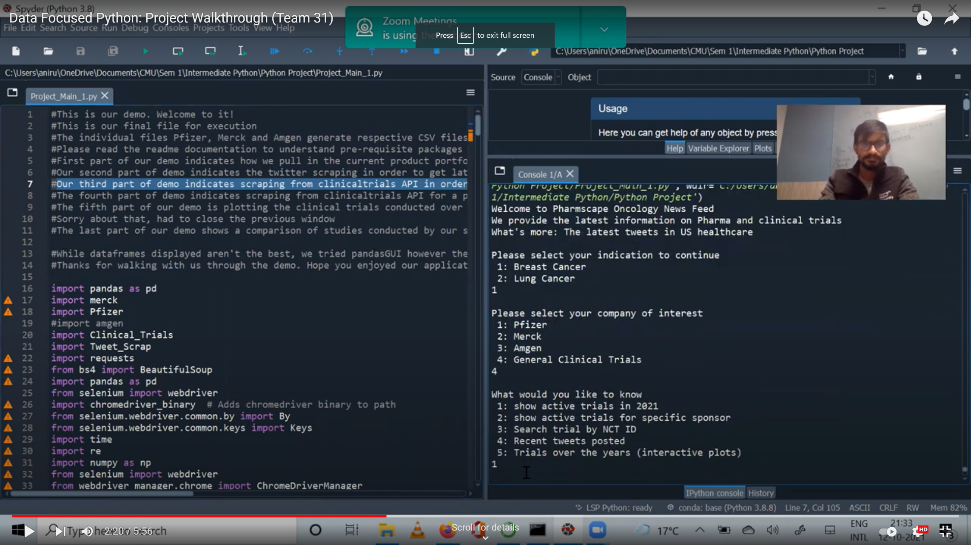

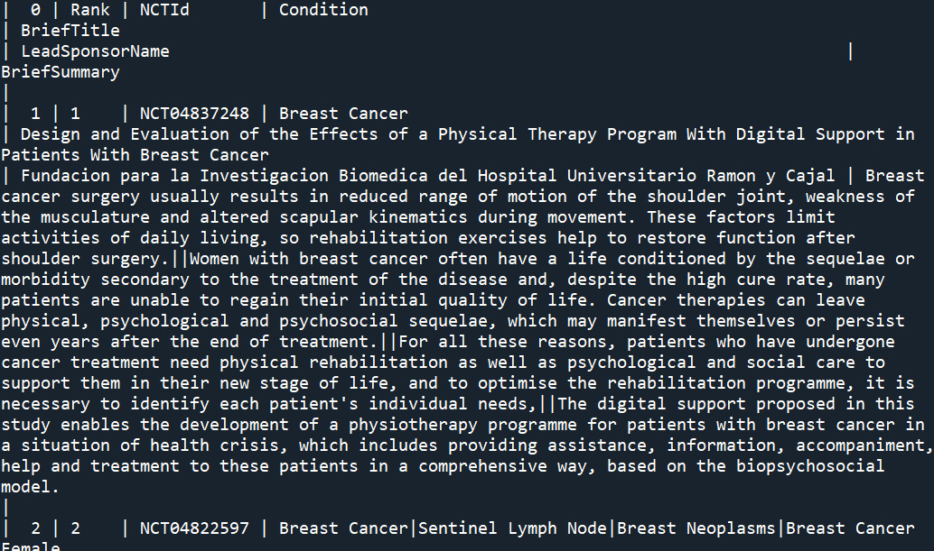

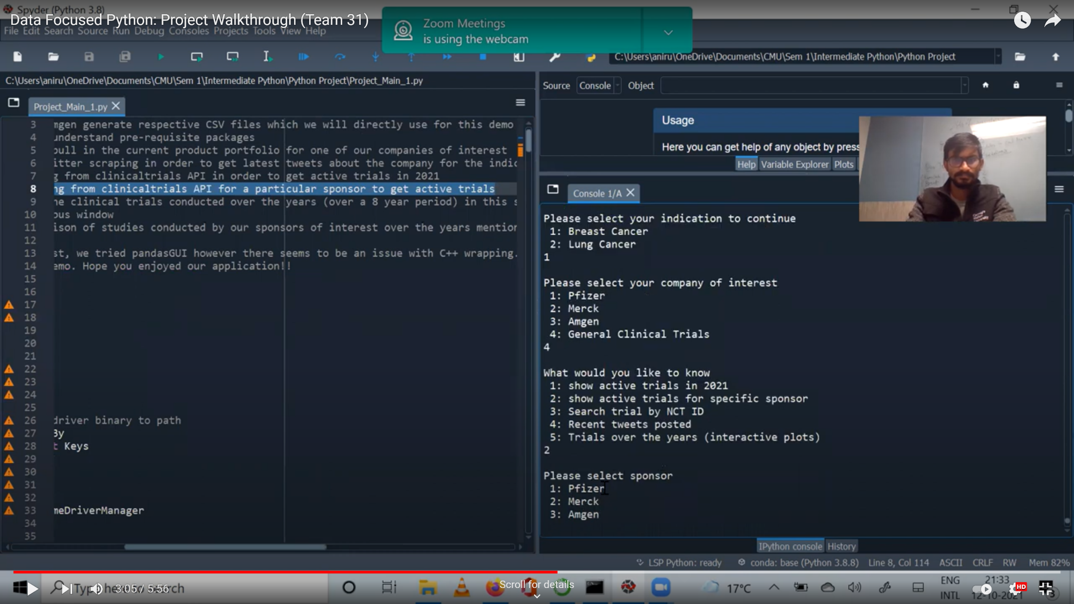

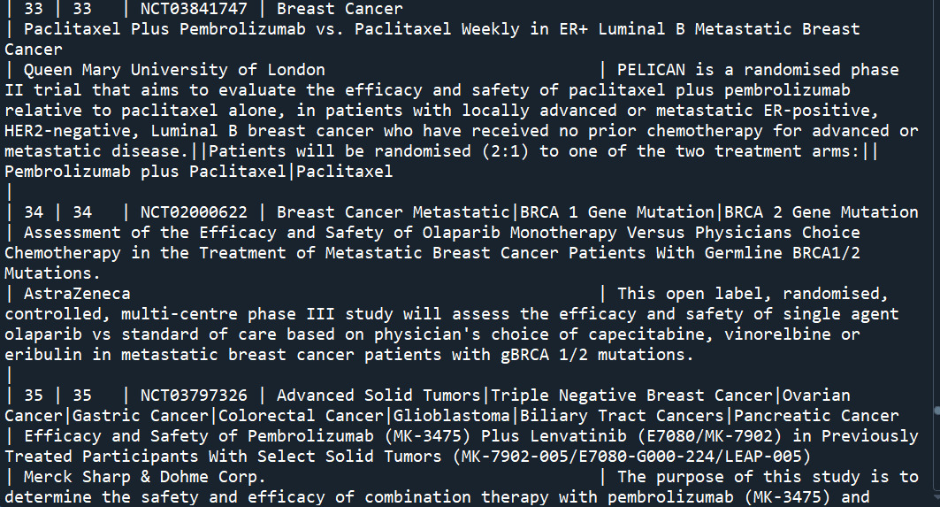

1. For viewing the plots, the number of years of your choice can be entered (maximum is 10 years).

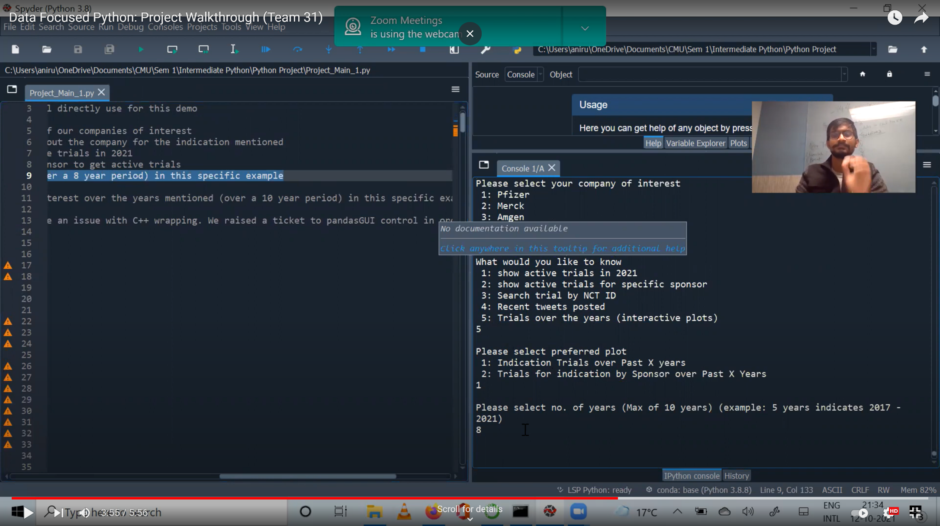

**Plot Output:**

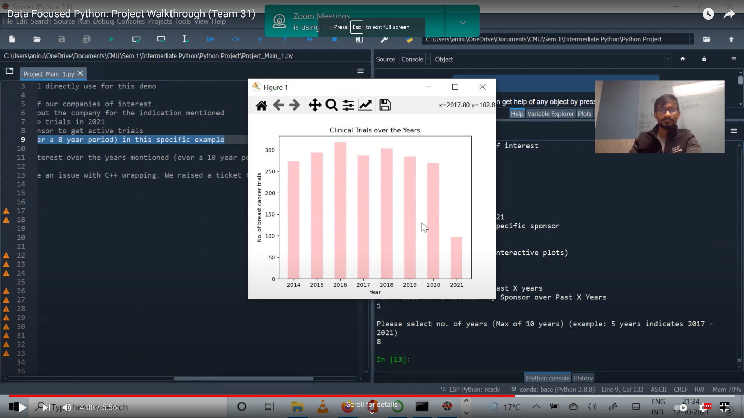

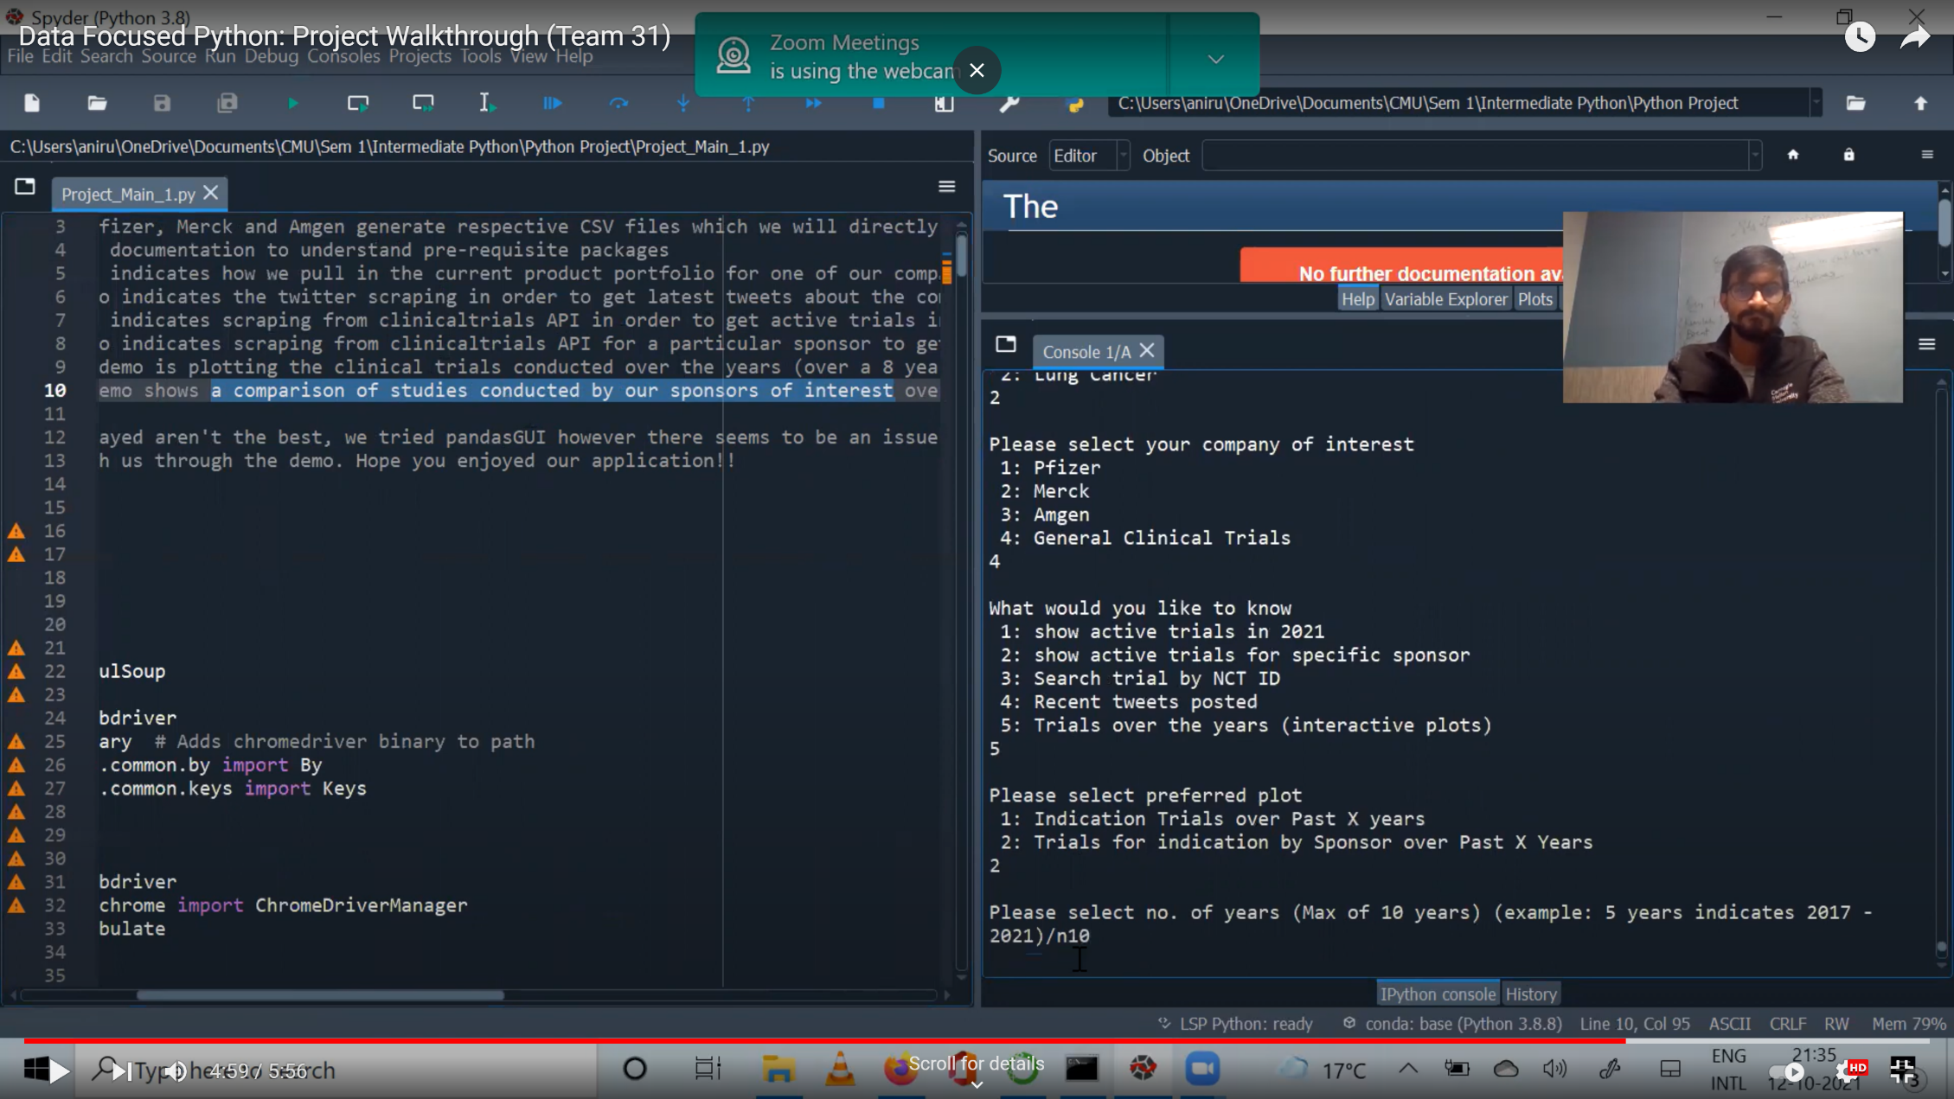

Plot Output:

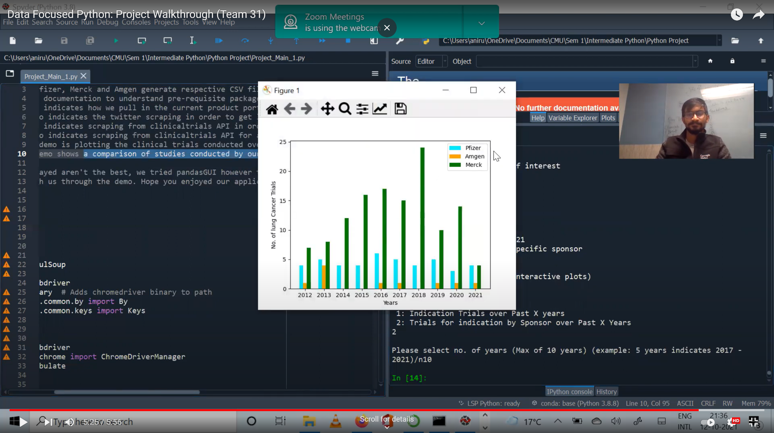

YOUTUBE LINK:

<https://youtu.be/eRh8wrZNQpk>